11. SIMPLE MACHINES

1. What is a simple machine? List the various types of simple machines.
Ans A machine that consists of few or no moving parts is called a simple machine. A bottle opener, a knife, a ramp and a wheel are some examples of simple machines. The various types of simple machines are the lever, the inclined plane, the pulley, the wheel-and-axle, the screw and the wedge.

2. Name the three kinds of levers. Explain with diagrams how they are different from each other.
Ans Levers are grouped into three classes:
i. Class 1 lever or First-class lever
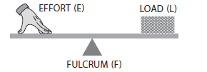
ii. Class 2 lever or Second-class lever
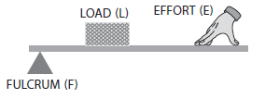
iii. Class 3 lever or Third-class lever
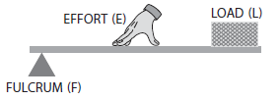
In class 1 levers, the fixed point or the fulcrum lies between the load and the effort.
In class 2 levers, the load lies between the fulcrum and the effort.
In class 3 levers, the effort lies between the load and the fulcrum.

3. What is a pulley? How does it make our work easy?
Ans A pulley consists of a wheel that is free to rotate about an axle passing through its centre.
- The rim of the wheel has raised edges. A rope or a string passes through the rim.
- A pulley is used to lift or move heavy objects. In a pulley, the axle is fixed on a rigid support such as a wall.
- One end of the rope passing over the pulley is tied to the load. The effort is applied at the other end of the rope.
- A pulley makes our job easy by changing the direction of force applied.

4. What is a screw? Describe its use.
Ans 1.A screw is a long nail with a spiral metal thread along its length.
2.We usually use screws to join two pieces of wood together.
3.A screw holds the pieces together more firmly than a nail does.
4.The head of the screw has a groove where a screwdriver can be fixed.
5.With every turn of the screwdriver, the screw moves easily into the wood.

5. What is a wedge? How does it work as a simple machine?
Ans 1.A wedge is a piece of wood or metal shaped like a triangle.
2.A wedge can be made by putting two
inclined planes together, back to back.
3.It has a thick edge and a thin edge.
4.A wedge acts as a simple machine because the thin edge is used to cut, slice or push things apart.

